CLASSROOM BRAIN BREAK GAMES

1.Area Dice Game
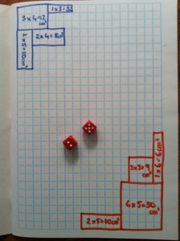
A game for 2 or 3 players.
Each player chooses a colour pencil or texta they will use in the game.
Players take turns rolling the dice, using the numbers that they rolled to draw the perimeter of a rectangle or square & writing the area in the middle of the shape.
Game ends when players run out of room to draw.
Winner is the player who has used the largest area/most squares.
This game is an old favourite. I used to play it when I was at school!
Permalink.
July 3, 2013
by denise Leave a comment

Resources: grid paper; two die per pair

2.Word Race
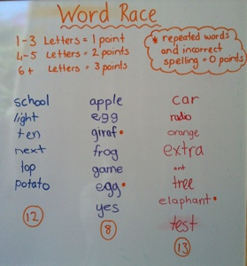
-Divide students into 3 or 4 teams (depending on how big your whiteboard is) & line them up in front of the white board.
-Write one word on the board for each team.
-One person from each team will go to the board to write a word that starts with the last letter of your word.
-The next person in their team then has to think of a word that starts with the last letter of the word their team member wrote.
-Students continue taking turns writing words on the board until you stop the game.
-You can stop when groups start running out of space to write or after a set amount of time.
-Add up each team’s points.
1-3 Letters = 1 point
4-5 Letters = 2 points
6+ Letters = 3 points
(Words that have been repeated or are incorrect do not count.)
-The team with the most points wins
by denise Leave a comment

3.Beetle Dice Game
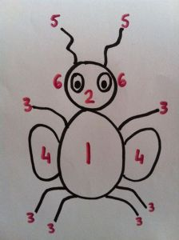
Split class into pairs or groups of 3
1 dice for each group
Paper & pencil for each player
Students take turns rolling the dice.
If they roll:
1 – draw the body*
2 – draw the head**
3 – draw a leg (need six legs)
4 – draw a wing (need two wings)
5 – draw an antenna (need two)
6 – draw an eye (need two)
*need to roll a 1 & draw the body before they can draw any other part!
**need to roll a 2 & draw the head before drawing the eyes or antennae
First student to finish drawing the beetle is the winner.
Resources: One dice per group, paper

4.Good Afternoon Judge
Choose one student to be the judge. They stand up the front with their back to the class & their eyes closed.
Without saying their name, choose another student to say “Good afternoon Judge” in a disguised voice.
The student up the front then turns around & has three guesses of who they think said it.
If they get it right they have another turn, if they can’t guess the student who managed to trick them becomes the new Judge.
Simple idea but kids love it!
They love being the detective but most of all they love coming up with silly voices to try to trick the Judge!
Great way to end the day after students have packed up the classroom.

5.The Ummm Game
The classroom teacher that I did relief work for today, reminded me of this oral language game I used to play when I was a classroom teacher.
-Write topics on small pieces of paper (eg: food, weather, birthdays, homework) & place in a container.
-Choose a student to come up to the front & select a piece of paper without looking.
– The student then has to talk about this topic, as the teacher times them.
– Time stops & the student is out as soon as they say “um” or “uh”.
– Choose another student to come up to choose a topic & have a go. Keep choosing students for as long as you’d like to play the game.
– Winner is whoever can speak the longest without saying “um”.
It’s harder than it sounds!!! I’ve had some students who can’t believe that the first word out of their own mouth is (yep, you guessed it!) “um!”

6.Silent Ball
Have everyone stand up at their desk. Students should toss a ball to each other. If a student drops the ball or talks, he or she should sit down. Play continues until only one student is standing. If this is too easy for your students, you could have them stand on one foot or only use their left hand, etc.
Categories: Literacy, Quick Games | Tags: classroom game, literacy game, Spelling, spelling game | Permalink.
June 23, 2013
by denise Leave a comment

7.Silent Ball Challenge!
Kids need a brain break? Not enough time or too cold & wet outside for a fitness game? Here’s a quick indoor game that kids love!
Objective of the game: to get every student to catch & throw the ball, silently & without dropping it, in the least amount of time.
-Students, standing up, spread around the room.
-Hand one student a soft medium/small sized ball.
-Teacher times the students
-Students pass the ball silently to each other. Once they throw the ball they must sit down on the floor, where they are.
-If anyone talks or drops the ball everyone must stand up & the timer is set again!
-encourage team work & strategy so that they can finish the challenge!

Resource: Small soft ball

8.Simon Says Draw!
This is a great listening & giving instructions activity. It’s also a bit of fun.
Without letting the students see your work, draw and call out instructions for them to copy. Try to make some instructions more specific than others. Also throw in a few instructions that don’t begin with ‘Simon Says’ to see how carefully the students are listening!
Eg – Simon says draw a large blue rectangle
– Simon Says to draw eyes towards the top of the rectangle
– Draw a yellow oval in the bottom right hand corner of the rectangle
– Simon says to draw orange spikes coming out from the top of the rectangle
– Simon says to draw a green triangle in the centre of the rectangle
When you’ve finished your drawing get everyone to reveal their pictures. Categories: Fitness Fun, Quick Games | Tags: indoor game, silent ball, team work | Permalink.

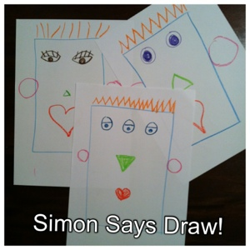

Resources: Coloured pencils per student; paper

9.I’m Going Into Space
Packed up a little early? Have a spare 5 minutes? Here’s a game that requires no equipment & can be adapted to suit the class.
Tell the students that you’re going into space. You have an empty rocket that has room to fit them all but they need to bring something special on board if they want to be allowed to come along.
This something special fits a special rule, that you have predetermined, but cannot reveal. They need to guess what it is!
Some Example Rules:
– needs to start with the letter ‘D’ (“Can I bring dog?” ” Yes you can come in my rocket into space.”
“Can I bring icecream?” “Oh! I love icecream! But no, you cannot come in my rocket!”)
– needs to start with the same letter as their first name
– has a double letter in the word
– has only 3 letters
– is something you can eat
If they get stuck you may need to give them a few examples of what they CAN bring, to see if they can work out the pattern.

10.Word Race
-Divide students into 3 or 4 teams (depending on how big your whiteboard is) & line them up in front of the white board.
-Write one word on the board for each team.
-One person from each team will go to the board to write a word that starts with the last letter of your word.
-The next person in their team then has to think of a word that starts with the last letter of the word their team member wrote.
-Students continue taking turns writing words on the board until you stop the game.
-You can stop when groups start running out of space to write or after a set amount of time.
-Add up each team’s points.
1-3 Letters = 1 point
4-5 Letters = 2 points
6+ Letters = 3 points
(Words that have been repeated or are incorrect do not count.)
-The team with the most points wins.

11.Heads or Tails
– Teacher needs 2 coins or the virtual coin tosser that you can find a link to below.
– Students all stand up.
– They need to decide if they think the coin toss will be:
2 heads – put both hands on their head
2 tails – put both hands on their tailbone
1 head, 1 tail – one hand on head, one on tail
– Once everyone has decided teacher tosses the coins.
– Whoever is wrong must sit down.
– Game continues until there is only one remaining student!
Resources: 2 coins

12. TRUE OR FALSE
Series of questions/statements
True – students put hands on heads
False – students put hands on tails

Eliminate until a winner
Resources: STATEMENTS

13.SCISSORS PAPER ROCK - Elimination game

14.MATHS PLACE GAME - try to make highest or lowest using HTO places - cards drawn out
RESOURCES : Cards numbered 0-9

15.THINK OF A NUMBER BETWEEN 1-20

16.SIX SPOTS 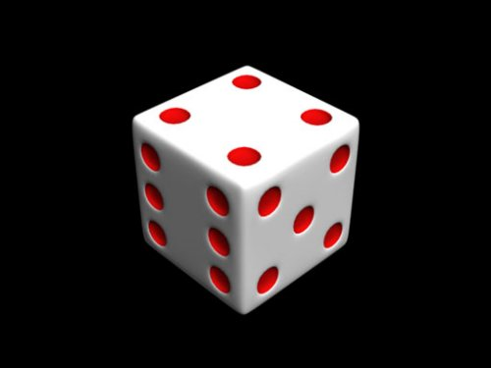

Cards with 1-6 are posted around room
Students choose to go to a card
Dice is rolled
Students at that card number sit down
Others redistribute
Continue until one or few winners

RESOURCES: Cards with 1-6; large dice

17. THE JUNK BAG
Bag with a collection of small household items
One item drawn out and students have to write or draw two other ways this item could be used

