Geometry Task 4
Problem Solving

Making your own protractor:
A protractor is a tool for measuring angles. By making your own protractor you can demonstrate your understanding of angles and your reasoning to draw them with their own self-made tool.
A protractor can be easily made by folding paper to make different angles.
THE PROBLEM: You need to accurately draw shapes with the correct angle, but you don't have a protractor.
- View the video: The amazing 'angle-a-tron' which gives you some very good clues to begin with.

- Draw a shape for each angle:
- 90°, 60°, 30°, 45°, 22.5°, 11.25°, 150°, 135°
- How many more different angles can you make by folding paper?
Create a display of angles drawn and shape patterns created using an 'angle-a-tron'.

The amazing 'angle-a-tron'

https://education.abc.net.au/home#!/media/1003966/

Geometry Task 3

Stain-Glass Geometry

- Using coloured paper, create geometric shapes to fill the page to create a ‘stain-glassed window’ look.
- Use crayon to colour each of the sections leaving a very small border around each shape so the colour of the paper can be seen.
- **You might like to try an create a stain glass with your name inside.
- When you have finished, give it to the teacher to create a big mural of stain-glass fo the classroom! ;)

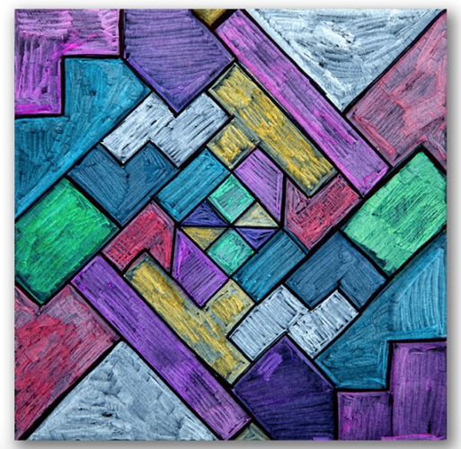

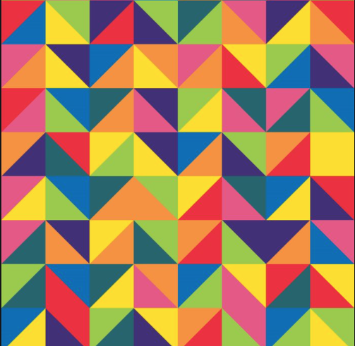

Geometry Task 5

SUNDIAL INVESTIGATION

- Read the booklet about the History of Sundials. You are not expected to know, understand or learn it all BUT, it demonstrates how geometry mathematics was used to develop items we use and rely on every day – a watch or a clock!
- Use the instruction sheet to make the sundial and answer the questions on the sheet!
- You need to test the sundial so negotiate with your teacher a good time to do so.
- Find 1 other type of sundial that you could make! – you’ll need to research or get creative.

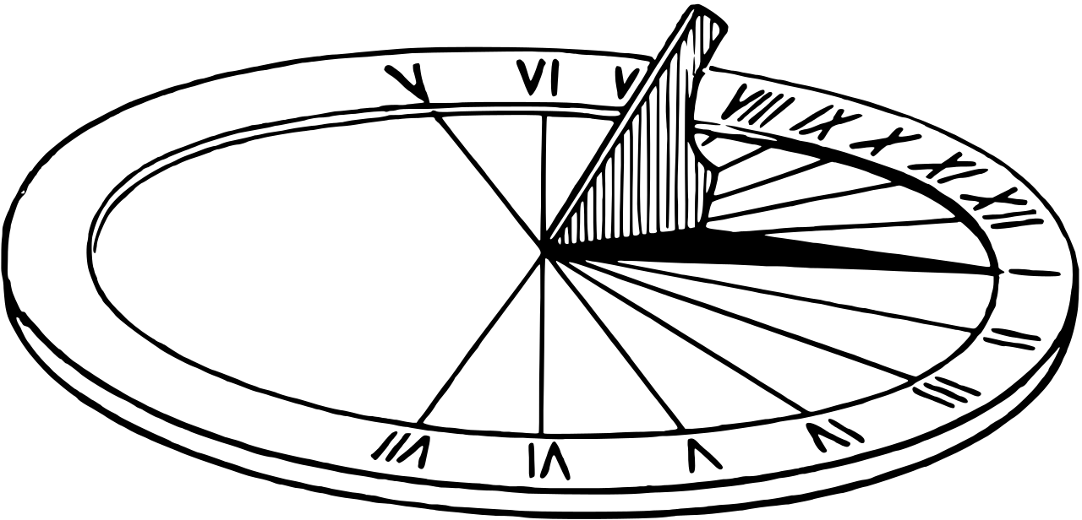
This Photo by Unknown Author is licensed under CC BY-SA

Geometry Task 7

Origami

Origami. The Japanese art of paper folding is obviously geometrical in nature.

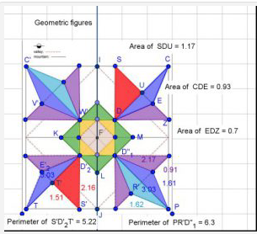
EXAMPLE OF GEOMETRY AND ORIGMAI

- See if you can follow the instructions to make this origami jumping frog!
- You will find paper with your teacher.
- Have fun!

THE ORIGAMI JUMPING FROG
